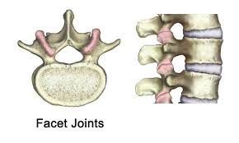
Lumbar Facet Hypertrophy
- Degeneration and enlargement of facet joints
- Each vertebra has two facet joints, one on each side. They are like the “knuckles” of the spine. They are small joints that have cartilage lining like other joints in your body. These wear down over time, with obesity, and with trauma (ex: MVA). Sometimes you have facet disease without any other cause just due to your genetics.
- Facet joints are meant to provide flexibility, stability, and support to the spine
- Facet joints provide availability for the back to turn and twist and/or bend forward to pick things up
- Enlargement of facet joints can cause pressure on the surrounding spinal nerves and can cause radiating nerve type pains
Symptoms of Lumbar Facet Disease
- Stiffness, discomfort when leaning backward, joint swelling, decreased mobility, hunched back, muscle spasms and/or weakness, tenderness near inflamed facet joints
- May experience pain that radiates to buttock, hip, and upper thigh
- Sometimes difficult to diagnose because can present like herniated disc, spinal stenosis, hip pains.
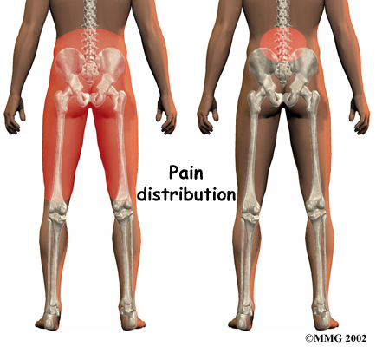

- Figuring out facet disease can involve process of elimination. An injection can help to do this. If your pain goes away with a facet injection, then we know this is where your pain is coming from.

